**Hands on 6**

1. Select Kubernetes Services

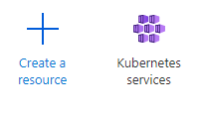

1. Select Add Kubernetes cluster

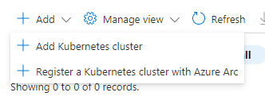

1. Change the node size

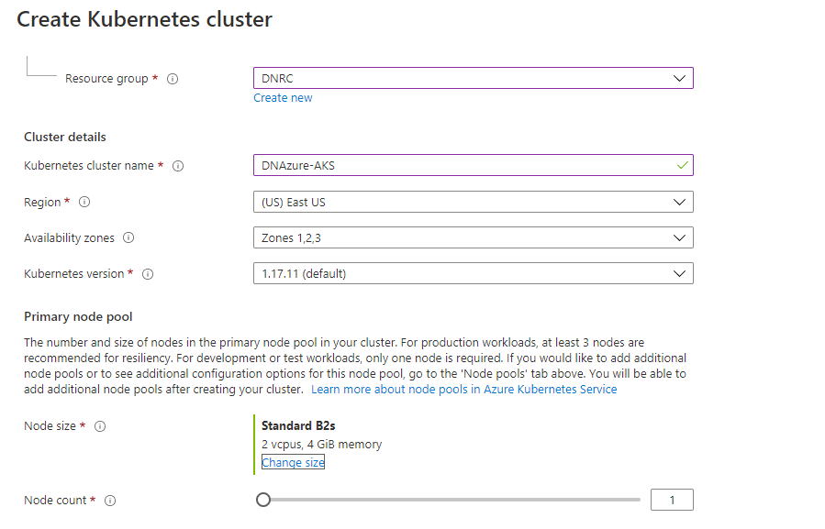

1. Check for validation

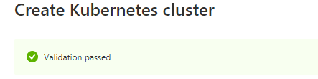

1. Go to resource to check for the creation

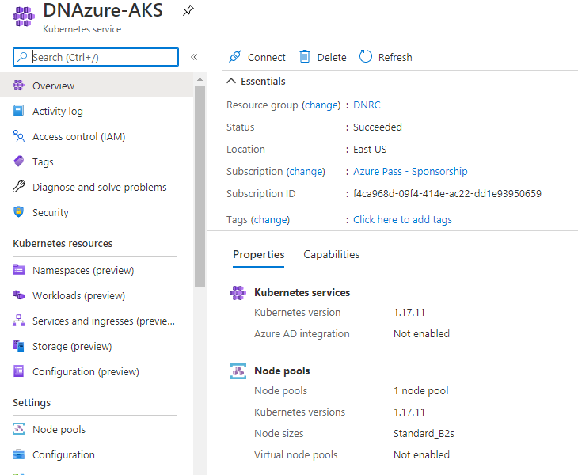

Container Registry

1. Search for Container Registry and click on it.

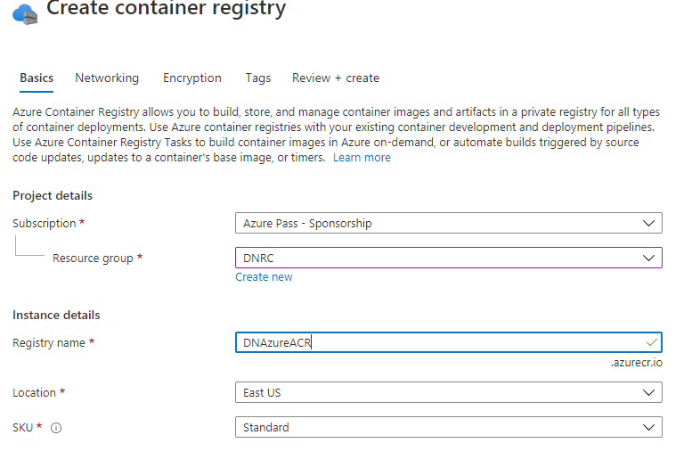

1. Check for validation

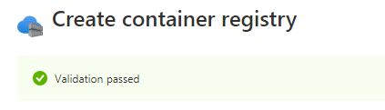

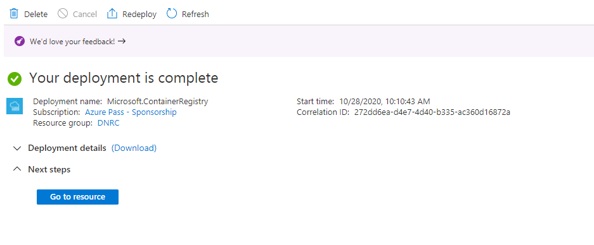

1. Go to the resource

